# **Task#01:**

## **First come First serve:**

### **Code:**

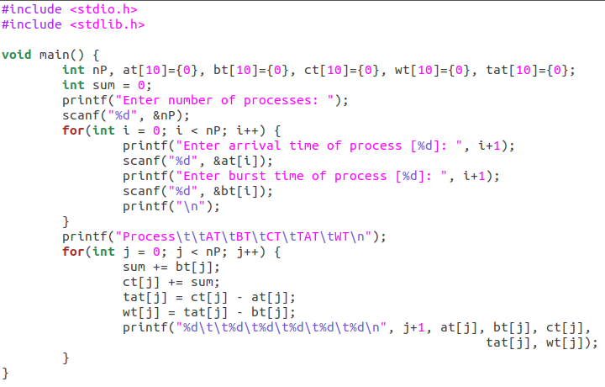

### **Output:**

